

Sustainable Fashion Curriculum at Textile Universities in Europe  
 –   
Development, Implementation and Evaluation of a Teaching Module for Educators

Project: 2020-1-DE01-KA203-005657

Title of the Lesson: Sustainable Fashion Business Models



Authors: Dr. Marcus Adam

Prof. Dr. Jochen Strähle

Marlen Wagner

Contact Data: Reutlingen University

TEXOVERSUM School of Textiles

E-mail: marcus.adam@reutlingen-university.de

 Ein Bild, das Text enthält.  

**Short Description of the Context:**

For the pupils, it is important to critical reflect on the given topic, rather than giving right/wrong answers. For this reason, the lecture is mainly based on discussion and group work. The setting should encourage collaboration and interaction. The lecture hall should be comfortable and inviting, with plenty of seating options and a clear view of the instructor. Desks should be arranged in a semi-circle or other arrangement which allows for easy conversation and discussion. Chairs should be comfortable and supportive, and the lecture hall should be well-lit. Whiteboards or flipcharts can be used to facilitate the discussion. The instructor should also have a laptop or other device to access multimedia presentations, as well as a projector to display slides or other visuals. In addition, the lecture hall should be equipped with WiFi and other technology to enable students to access online resources.

**Competences and Learning Objectives:**

After this unit the pupils should be able to …

* Know what fast fashion is
* Explain why and how fast fashion negatively impacts the environment
* List alternative consumption model
* Explain why these models might be more sustainable than others
* Know what a business model is
* Analyse and evaluate a business model of an alternative consumption model
* Reflect on the feasibility and the actual sustainable impact of such business models

Overview of Working Materials

I. Fast Fashion

II. Alternatives

III. Plan a clothing swap event

IV. Working on a business model

Sources

Engartner, T. & Tschirner, M. (2015). *Viel Mode für wenig Geld – ist das fair? Entscheidung im Unterricht Folge 01/2015*. Bundeszentrale für politische Bildung. <https://www.bpb.de/shop/materialien/entscheidung-im-unterricht/210606/viel-mode-fuer-wenig-geld-ist-das-fair/>

Muthu, S. S. (Ed.). (2019). *Fast fashion, fashion brands and sustainable consumption*. Berlin: Springer.

Osterwalder, A., & Pigneur, Y. (2010). Business model generation: a handbook for visionaries, game changers, and challengers (Vol. 1). John Wiley & Sons.

Thomas, D. (2019). *Fashionopolis: The price of fast fashion and the future of clothes.* Penguin Press.

Vasquez, R. (2022). *Overconsumption in the fashion industry.* Fashion Revolution.<https://www.fashionrevolution.org/overconsumption-in-the-fashion-industry/>

Verbraucherzentrale Rheinland-Pfalz (2023). NACHHALTIGE TEXTILIEN. Unterrichtsmaterial. <https://www.verbraucherzentrale-rlp.de/sites/default/files/2022-03/vz_unterrichtsmaterial-textilien_2022_final.pdf>

World University Servic (2020). Textile Industry - Global Challenges and Opportunities. NETZ Partnership for Development and Justice. <https://www.globaleslernen.de/sites/default/files/files/education-material/textilbildungsheft_englisch_web.pdf>

**I. Fast Fashion**

☞Instruction for the teacher:

**The pupils are already familiar with fashion overconsumption and its impact on the environment.**

Discuss with the pupils the concept of fast fashion:

Ask them what in their opinion fast fashion means and write the most important attributes on the board

**Potential discussion points:**

Fast fashion is a term used to describe the trend of producing and selling clothing and accessories that are inspired by the latest fashion trends but at a much lower cost. This type of fashion has become increasingly popular over the past few years because it allows people to purchase trendy items at a fraction of the cost that they would have to pay at a high-end retail store. The rise of fast fashion has had a major impact on the fashion industry. It has made fashion more accessible to people of all incomes and it has also allowed people to keep up with the latest trends without breaking the bank. Additionally, it has made it easier for fashion designers to bring their designs to market more quickly as well as allowing them to be more creative and innovative. Fast fashion has also had a major impact on the environment. Since these garments are cheaper and often made from lower quality materials, they don’t last as long as higher quality garments and end up in landfills much more quickly. Additionally, the production of fast fashion items often involves the use of more resources and energy than the production of more traditional fashion items. All in all, fast fashion has had a huge impact on the fashion industry and the environment. While it has made fashion more affordable and accessible to people of all incomes, it has also caused an increase in waste and pollution. It is important to be mindful of these impacts and to think carefully about our consumption of fast fashion items.

**II. Alternatives**

The key to more sustainable consumption is restraint. But giving up is not easy. And especially in the fashion industry, it is a no-go for many to not follow a new trend or to always wear the same clothes. But there are alternatives to buying new that are fun.

☞Instruction for the teacher:

Ask to think about alternatives to buying clothes first hand:

* Let them go together in groups (3-5 pupils) and write down alternatives
* Ask them to critically assess the environmental impact of each alternative – which one is “the best”?

**Possible alternatives to purchasing first hands:**

**Secondhand**:

A generally good alternative is to buy secondhand products. Pieces that others no longer want to wear get a longer life before they are finally sorted out. And they are usually cheaper than new items. The problem is that the secondhand market is no longer sold from private person to private person. The sale of used clothing has become a professional business. Due to the ever-worsening quality of old clothes, the pressure on prices is high, leading to poor working conditions and low wages, especially in the sorting sector. This is something that secondhand chains like to keep quiet about. It is worth taking a closer look here and questioning business practices. However, buying and selling secondhand between private individuals is definitely a sustainable alternative to buying new. And not only at clothing exchanges or flea markets: there are now platforms on the internet where private individuals offer used clothing, for example Vinted or Ebay.

**Swapping:**

Secondhand doesn't always mean buying and selling used clothes. Swapping clothes without any money changing hands is also an alternative to buying new.

**Repair:**

A tear in the jeans in the wrong place or holes in the socks are often a death sentence for the respective item of clothing, as buying new is quick and easy. But in recent years, repairing has come back into fashion, also because it saves money. Alteration shops are doing well, and in repair cafés you can sew under guidance, and on the internet people share their knowledge and publish instructions with which even beginners can carry out easy repair work on clothing themselves.

**Capsule Wardrobe:**

A capsule wardrobe is a wardrobe with as few items of clothing as possible. However, these are coordinated with each other so that they can all be combined - so many different outfits can be created from a few pieces and new pieces do not always have to be bought to be dressed variably. The concept was invented in the 1970s by Susie Faux from London, who ran a fashion boutique there. Modern fashion bloggers then picked it up. Strictly speaking, a perfect capsule wardrobe only consists of 37 pieces of clothing per season - including shoes. Accessories such as scarves, bags or jewellery are not included. Seasons are taken up by, for example, packing away winter jackets and unpacking summer jackets. The concept saves time and money. And it has a positive effect on a more sustainable approach to clothing: those who buy less new make fewer wrong purchases. Those who buy fewer new pieces and want to have them for longer pay more attention to quality and sustainability.

**Renting clothes**:

Renting clothes is the act of borrowing clothing items from a company or other individual for a specified period of time, usually for a fee. It is often done to wear garments that a person may not otherwise be able to afford or may not have access to. Renting clothes can also be used to try out different styles and trends without the commitment of buying them.

**III. Plan a clothing swap event**

☞Instruction for the teacher:

Ask the pupils to plan a clothing swap event for their school as a one–time event during which clothes are exchanged or a regular exchange platform (similar to an open bookshelf).

* They can make a To–Do list, divide tasks, set time limits etc.
* Especially with younger students, it is helpful to work with a person in charge (e.g. the teacher of the class) so that the participants can clarify practical issues.
* Ask the pupils to also prepare education material on why swapping clothes may benefit the environment but make sure that the event has a foremost fun character

**IV. Working on a business model**

A key for the success of alternative consumption models is how and if they can be monetarized. The pupils should now try to find a way how profit can be made with an alternative model.

☞Instruction for the teacher:

A useful tool to operationalize and visualize a business idea is the Business Model Canvas by Osterwalder and Pigneur (2010). A business model refers to the framework or plan that outlines how a company creates, delivers, and captures value. It describes the way a business operates, generates revenue, and sustains itself in the marketplace. A business model encompasses various elements, including the target customer segment, value proposition, revenue streams, cost structure, key activities, resources, and partnerships.

* Show and explain the Business Model Canvas to the pupils
* An agile tool to work with can e.g. be found here: <https://miro.com/app/board/uXjVMXWehMU=/>

**Explanation of the key components of the Business Model Canvas:**

1. Customer Segments: Identifying the specific groups or individuals that a company aims to serve with its products or services.
2. Value Proposition: Describing the unique value that a business offers to its customers, which addresses their needs, solves their problems, or fulfills their desires.
3. Revenue Streams: Outlining the sources of revenue for the company, which can come from sales of products, services, subscriptions, licensing, advertising, or other monetization strategies.
4. Cost Structure: Identifying the various costs and expenses associated with running the business, such as production costs, employee salaries, marketing expenses, infrastructure, and operational overhead.
5. Key Activities: Describing the core activities that a company needs to perform to deliver its value proposition, including production, marketing, distribution, customer support, research and development, etc.
6. Key Resources: Identifying the essential assets, capabilities, and resources required to operate the business effectively. This can include physical assets, intellectual property, human resources, technology, partnerships, and more.
7. Channels: Describing the methods or channels through which a company reaches and interacts with its customers to deliver its products or services, such as online platforms, physical stores, direct sales, or partnerships with distributors.
8. Customer Relationships: Describing how a company builds and maintains relationships with its customers, which can involve aspects like personal assistance, self-service, automated communication, community building, or dedicated account management
9. key partners refer to the external individuals, organizations, or entities that a company collaborates with to enhance its operations, leverage resources, and deliver value to its customers. Key partners can play various roles and contribute to different aspects of a business. Here are some common types of key partners:

Suppliers: These are the entities that provide the necessary raw materials, components, or resources for the company to produce its products or deliver its services.

Manufacturers: In some cases, companies may partner with manufacturers to outsource the production of their products. This allows them to focus on other aspects of their business while leveraging the expertise and capabilities of specialized manufacturers.

Distributors and Resellers: These partners help a company reach its target market by distributing or reselling its products or services. They often have established distribution networks or customer relationships that the company can benefit from.

Strategic Alliances: Companies may form strategic partnerships with other organizations to achieve mutual goals. These alliances can involve sharing resources, expertise, or technology to create new opportunities or expand into new markets.

Co-creators: Some companies collaborate with customers, suppliers, or other stakeholders to co-create products or services. This approach involves involving partners in the innovation and development process to create solutions that better meet customer needs.

Technology Providers: Technology partners can provide software platforms, tools, or infrastructure that enhance a company's operations, such as cloud service providers, software developers, or data analytics companies.

Marketing and Advertising Partners: Companies may collaborate with marketing agencies, influencers, or media outlets to promote their products or services and reach their target audience effectively.

Financial Partners: These include banks, investors, or venture capitalists that provide financial support, such as loans, investments, or funding, to help the company grow and expand its operations.

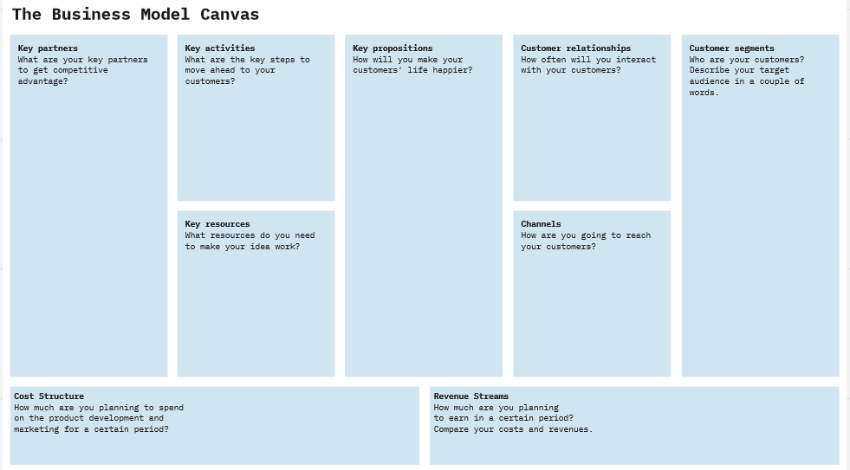

☞Instruction for the teacher:

The pupils are now supposed to elaborate a business model:

* Ask them to go together in groups (3-5 pupils per group)
* Each group choses one alternative consumption model.
* Ask them to look for providers of such a business and think about how they work to put it into practice
* Ask each group to fill in the Business Model Canvas for their respective model
* Each group presents its business model. Discuss: is this feasible? Does it work? Is it sustainable

**Potential Solution for a renting business model:**

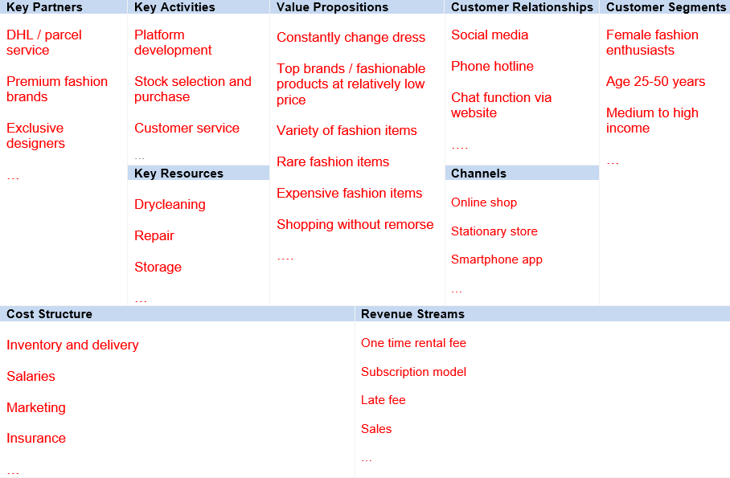

**Potential discussion of sustainability impact:**

Flatrate does not solve consumption addiction + permanent shipment

Frequency of rentals before item is sorted out

Currently only works high-end/premium – not the core problem --- Rental model 🡪 leasing model 🡪 sale model: rented items advertised for sale

Origin of item: remainder of stock or extra production for new market